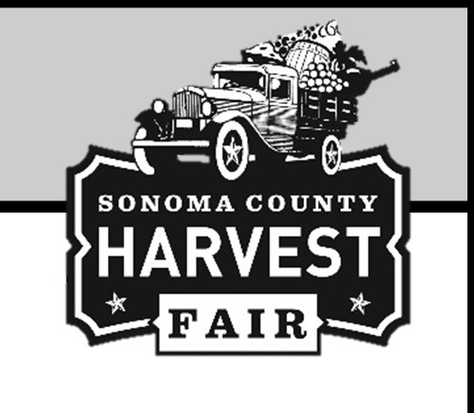

Sonoma County Harvest Fair Presents Professional Food Competition

2025 OLIVE OIL

**ENTRY FEE:** $20.00 per entry

**JUDGING COORDINATOR:** Anne Vercelli, Healdsburg

**ENTRIES CLOSE: *Online Entry -*** May 31, 11:59 p.m.

***Paper Entry -*** May 31, 5:00 p.m., Fair Entry (Admin) Office, Fairgrounds

**EXHIBITS RECEIVED:** May 27-June 2, 2025; 9:00 a.m. to 5:00 p.m., Fair Entry (Admin) Office, Fairgrounds

**JUDGING:** June 17th, 10:00 a.m. Showcase Café, Sonoma County Fairgrounds

**SUBMIT:** 2 bottles or containers per entry

# RULES FOR JUDGING

* Oil entered must be California grown and custom blended by Sonoma County processor or made with olives grown in Sonoma County and designated on the label to be eligible.
* Exhibitors may only enter items that are intended to be marketed and sold by their businesses.
* Exhibitors may not view the judging.
* The food will be judged on the Danish system of judging with Gold, Silver, and Bronze awarded to the winners in each class. Best of Show winners are picked from the Gold winners.
* All food that is entered into the competition must be available to the public at your place of business.
* Awards (Gold, Silver, Bronze) are specific to the year the product/entry earned them and if used for personal promotion must be publicized/marketed appropriately.
* Gold, Silver, and Bronze awards will be provided as rosettes, and can be picked up at the office following the judging. Medals can be purchased at an additional cost. Consult staff for details.
* Mono cultivar oils must contain 100% of the named cultivar.

# EXHIBITOR ORIENTATION

If you are interested in gaining some informative tips for preparing your entries for the competition, please contact Anne Vercelli to make an appointment. Call Anne at (707) 953-0332.

## Awards Offered per Class Gold, Silver, & Bronze Rosettes

**SECTION 51 - SONOMA COUNTY GROWN SECTION 52 - CALIFORNIA GROWN**

1. Delicate (light fruitiness intensity)
2. Medium (medium fruitiness intensity)
3. Robust (intense fruitiness)

*Please be sure to state Cultivar (Olive Varietal) on Entry Form*

## SECTION 53 – CALIFORNIA GROWN FLAVORED

1. Citrus – state flavor
2. Herb – state flavor
3. Any other – state flavor

## YEARLY AWARDS: SPONSOR

Best of Show Olive Oil Plaque by Teejay & Jamie Lowe

**2024 Winner: Gold Ridge Organic Farms**